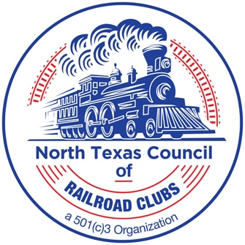
AGENDA

February 17, 2026

- Future Show Dates: Fall Plano: Sep 26- 27, 2026
Dallas Area: January 16-17, 2027

- Treasurer Report: Balance: _____________________

- Attendance

- Table Sales Fall 281_____ January __299_

- Old Business
  - Submittal of any outstanding 25/26 show season expenses
  - Submit Club Information Forms

- New Business
  - Board of Directors meeting
  - Nomination for Officers & Directors
  - January Show results
  - Vote on 2027 January Show
  - 2026/2027 Show Season Participation commitment

- Other Business

- Next meeting is on Mar 17, 2026

2026/2027 Council Meeting dates:
Mar 17, Apr 16, May 19, Jun 18, July 16, Aug 20, Sep 17, Oct 20, Nov 17, Dec 15, Jan 12, Feb 16

